|  |  |  |  |
| --- | --- | --- | --- |
| 2022/2 『자료구조』실습/과제 보고서 | | | |
| 제목 | 2장 실습( o ) 과제( ) | 제출일자 | 2022.  09 .    15 . |
| 학번 | 201911608 | 이름 | 김지환 |

|  |
| --- |
| #include <stdio.h>  #include <time.h>  int factorial(int n){  if (n < 1) return 1;  return n*factorial(n-1);  }  long long int sqr(int n) {  if(n<1) return 1;  if(n==1) return 10;  return 10*sqr(n-1);  }  int main() {  int start;  printf("순환\n");  for (int i = 0; i<13; i++) {  start = clock();  printf("%d! = %d, ", i, factorial(i));  printf("실행시간 = %.3lf(sec)\n",(double)(clock() - start) / CLOCKS_PER_SEC);  }  printf("\n반복\n");  for(int i = 0; i<13; i++){  int fact = 1;  start = clock();  if (i<=1) printf("%d! = 1, ",i);  else {  for(int j=2;j<=i;j++) fact*=j;  printf("%d! = %d, ", i, fact);  }  printf("실행시간 = %.3lf(sec)\n",(double)(clock() - start) / CLOCKS_PER_SEC);  }  printf("\n순환\n");  for (int i = 1; i<21; i++) {  start = clock();  printf("10^%d = %lld, ",i,sqr(i));  printf("실행시간 = %.3lf(sec)\n",(double)(clock() - start) / CLOCKS_PER_SEC);  }    printf("\n반복\n");  for (int i = 1; i<21; i++) {  int j = 1;  long long int sqrt = 10;  start = clock();  while(j!=i){  j++;  sqrt*=10;  }  printf("10^%d = %lld, ", i, sqrt);  printf("실행시간 = %.3lf(sec)\n",(double)(clock() - start) / CLOCKS_PER_SEC);  }  return 0;  } |

1) 0! ~ 12! 계산 시간

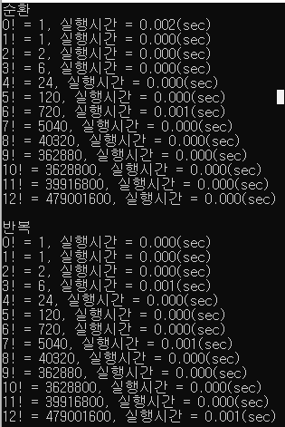

비교표

|  |  |  |  |  |  |  |  |  |  |  |  |  |  |
| --- | --- | --- | --- | --- | --- | --- | --- | --- | --- | --- | --- | --- | --- |
| 팩토리얼 | 0! | 1! | 2! | 3! | 4! | 5! | 6! | 7! | 8! | 9! | 10! | 11! | 12! |
| 실행시간 | 0.0s | 0.0s | 0.0s | 0.0s | 0.0s | 0.0s | 0.0s | 0.0s | 0.0s | 0.0s | 0.0s | 0.0s | 0.0s |

3) 10^n 의 계산시간 측정

